System Analysis UML Modeling
Tools used for drawing diagrams:
Microsoft Visio 2013
Usecase Diagram:
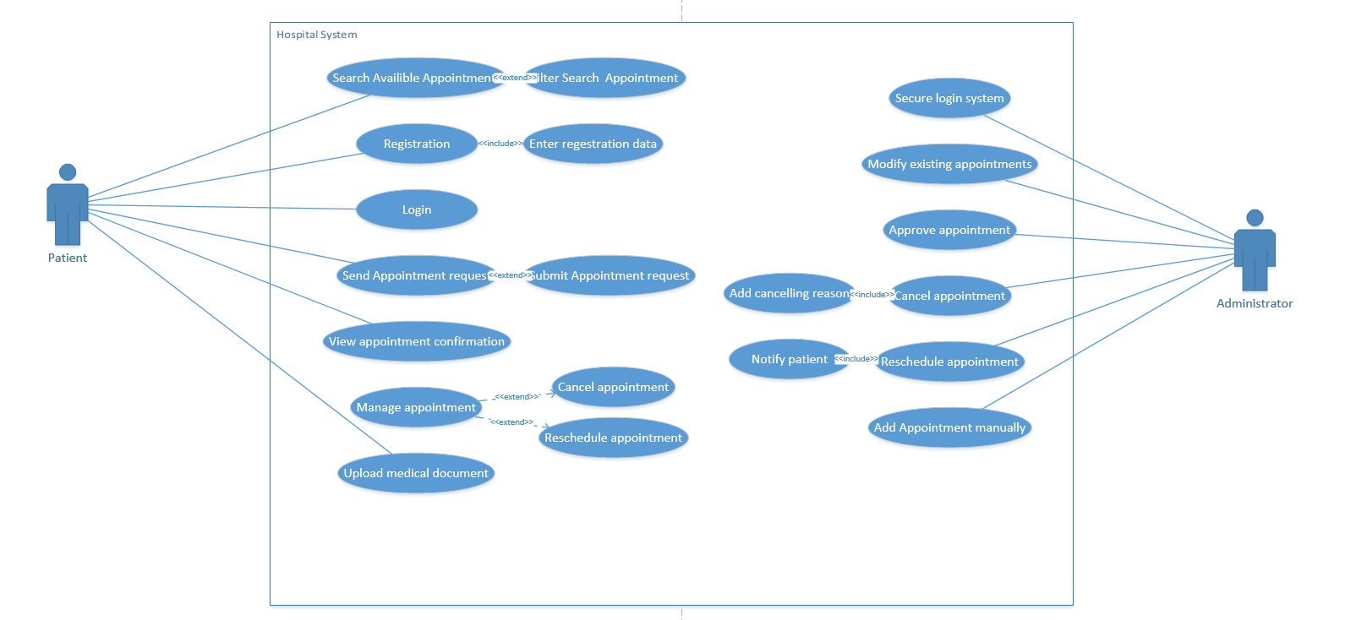
The usecase diagram shows the different cases of usage which the patient can do in the hospital system
Patinet and Administrator are the main users of the system as provided.
Patient can Search for available appointments or create a new one and edit its details and manage his own appointment or upload his medical document
Administrator can Manage appointments or approve it or cancel it with reason or reschedule an appointment with notifying the user.

Activity Diagram:
in this activity diagram showing 2 flows of patint accesing the system and the system interaction for the actions of the user detailed in the UML:
